1🡺

* Programs written in Java are executed by the Java virtual machine (JVM). The JVM is a special program that knows how to execute programs written in Java
* In the Java programming language, each command is written on its own line. A semicolon must be placed at the end of a command."
* System.out.println("Humans and robots are friends forever");
* "A command is like a room. In the Java programming language, a command can't exist on its own. It's part of a function (in Java, 'functions' are also called 'methods'). A method is part of a class. In other words, a class is divided into methods and methods are divided into commands."
* "Programs in Java consist of classes. There might be tens of thousands of classes. A minimal program is one class. For each class, a separate file is created. The name of the file matches the name of the class.”
* "If you want to describe a cat in the program, then you’ll have to create a file Cat.java and declare the Cat class in it, etc."
* "The files contain code (text) written in the Java programing language. Usually a class’s code consists of the 'class name' and 'class body'. The class body is written in curly brackets
* The class body may contain variables (also known as data) and methods ('functions')."

Example

**public** **class** Home

{

**int** a;

**int** b;

**public** **static** **void** main(String[] args)

{

System.out.print("1");

}

**public** **static** **double** pi()

{

**return** 3.14;

}

}

* int a and int b variables, and main and pi method
* minimal Code :-

**public** **class** Home

{

//Unchangeable part

**public** **static** **void** main(String[] args)

{

CODE **FOR** THE METHOD

}

}

2🡺

Public static void main(String args[]){

}

Here Public 🡺 Access modifier

Static 🡺 that we didn’t need any object to call it

Void 🡺 no return

Main 🡺 function name where every codes start from

3🡺 Taking input from the user

First we have to import class java.util.Scanner ; and we can use the Scanner

Scanner <name> = new Scanner(System.in); here name could be anything

Scanner is a input taking class where we define it as new scanner to make our own instance of that class

Eg.

{

Scanner inp = new Scanner(System.in);

        int a = inp.nextInt();

        System.out.println(a+100);

        String b = inp.next();

        System.out.println(b+"world");

        // .next() would take only one word

        String name = inp.next();

        System.out.println(name);

        //.nextline() take full sentence

        String fullName = inp.nextLine();

        System.out.println(fullName);

        inp.close();

}

4🡺JVM , JRE and JDK

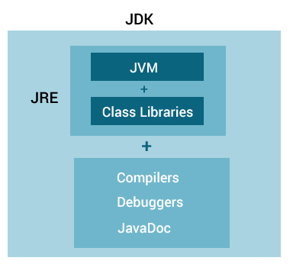

5🡺